1. Db backup before Upgrade starts

database name : hexagon25jan2024

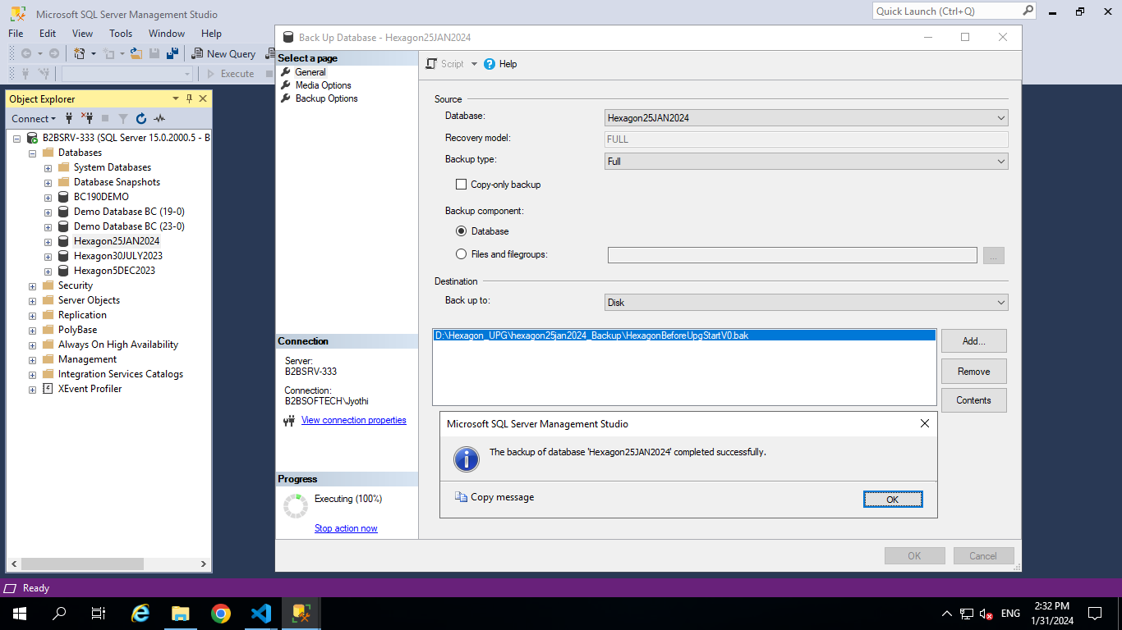

1. Open BC19 Administration shell with run as administrator

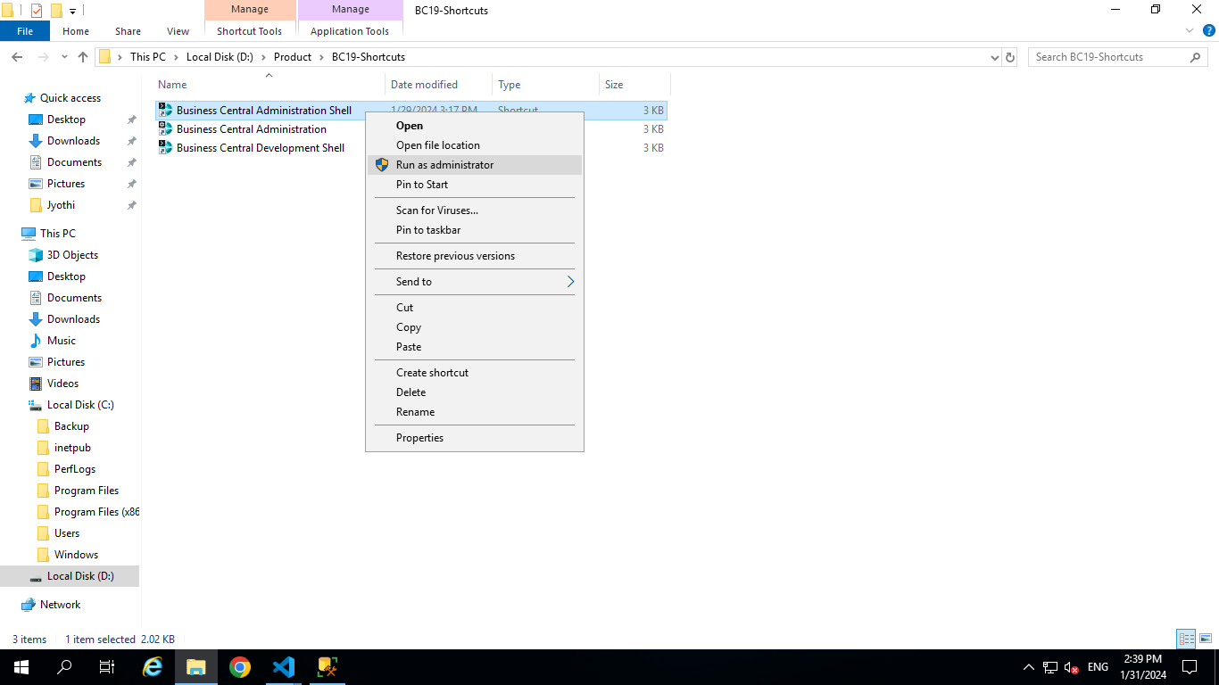

Get-NAVAppInfo -ServerInstance Hexagon25JAN2024 | format-table Name,version

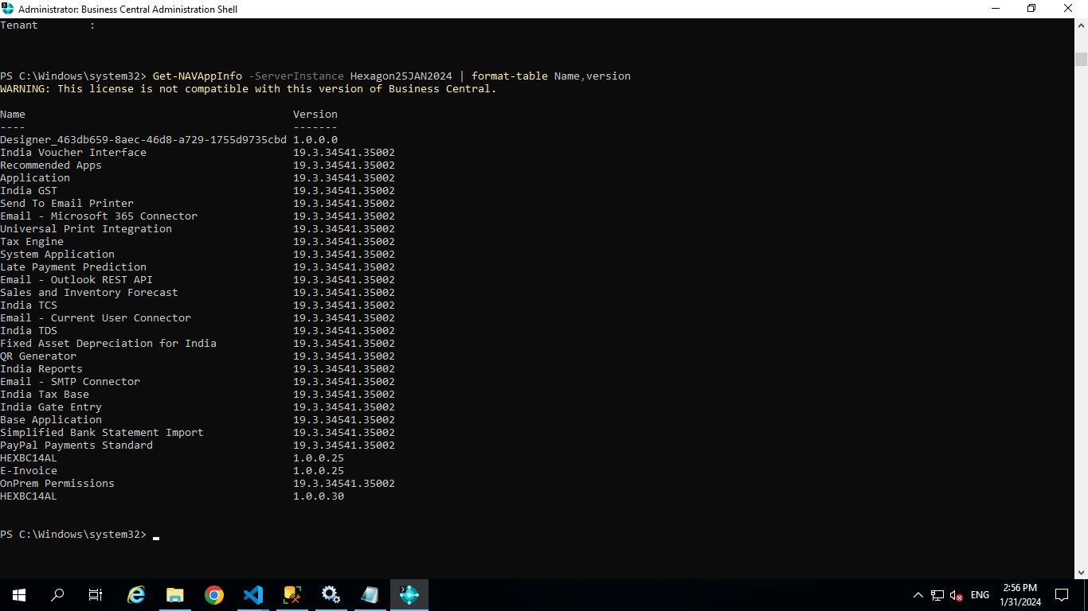

Get-NAVAppInfo -ServerInstance Hexagon25JAN2024 -SymbolsOnly | % { Unpublish-NAVApp -ServerInstance Hexagon25JAN2024 -Name $_.Name -Version $_.Version }

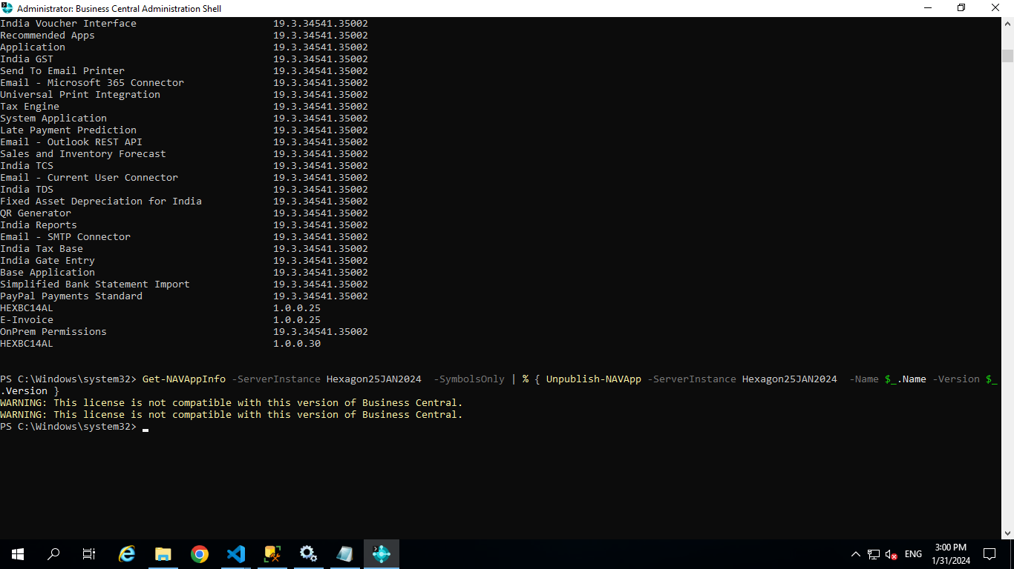

Get-NAVAppInfo -ServerInstance Hexagon25JAN2024 | % { Uninstall-NAVApp -ServerInstance Hexagon25JAN2024 -Name $_.Name -Version $_.Version }

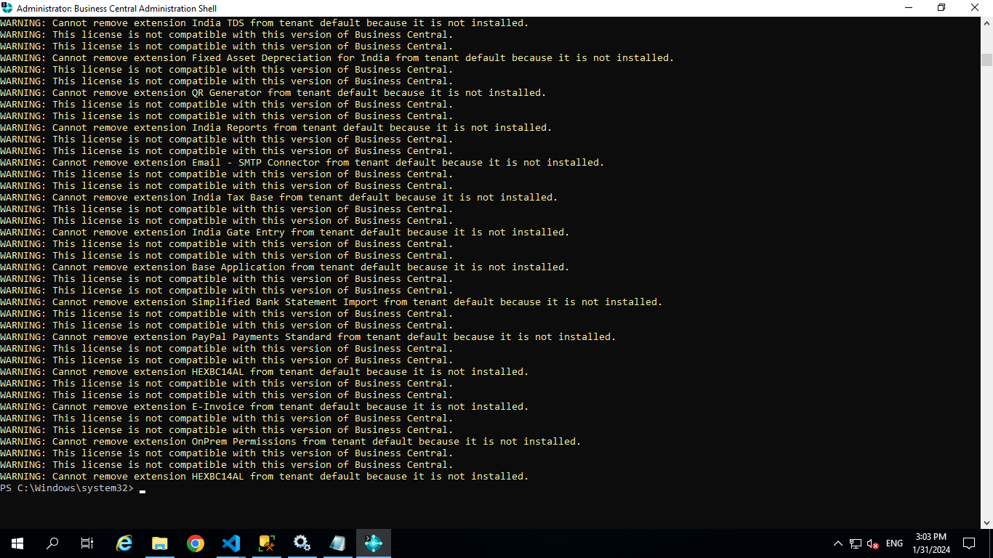

Check the whether the Apps Are Unpublished and Uninstalled by running the below Command

Get-NAVAppInfo -ServerInstance Hexagon25JAN2024 | format-table Name,version

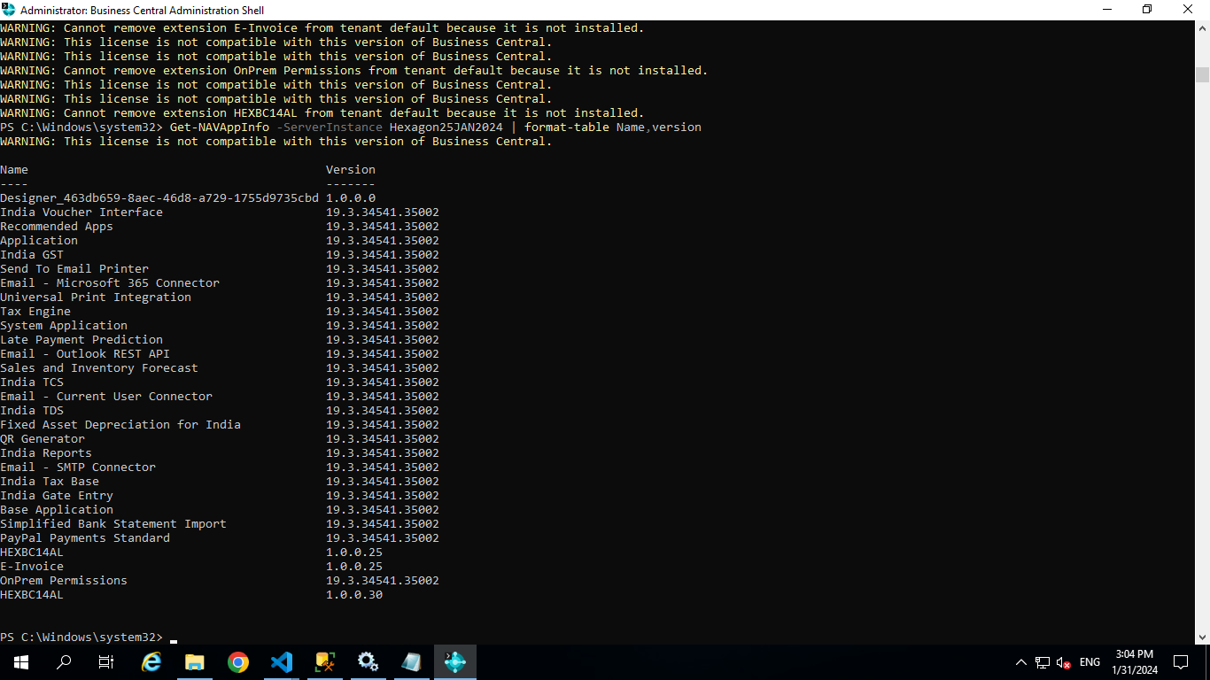

Name Version

---- -------

Designer_463db659-8aec-46d8-a729-1755d9735cbd 1.0.0.0

India Voucher Interface 19.3.34541.35002

Recommended Apps 19.3.34541.35002

Application 19.3.34541.35002

India GST 19.3.34541.35002

Send To Email Printer 19.3.34541.35002

Email - Microsoft 365 Connector 19.3.34541.35002

Universal Print Integration 19.3.34541.35002

Tax Engine 19.3.34541.35002

System Application 19.3.34541.35002

Late Payment Prediction 19.3.34541.35002

Email - Outlook REST API 19.3.34541.35002

Sales and Inventory Forecast 19.3.34541.35002

India TCS 19.3.34541.35002

Email - Current User Connector 19.3.34541.35002

India TDS 19.3.34541.35002

Fixed Asset Depreciation for India 19.3.34541.35002

QR Generator 19.3.34541.35002

India Reports 19.3.34541.35002

Email - SMTP Connector 19.3.34541.35002

India Tax Base 19.3.34541.35002

India Gate Entry 19.3.34541.35002

Base Application 19.3.34541.35002

Simplified Bank Statement Import 19.3.34541.35002

PayPal Payments Standard 19.3.34541.35002

HEXBC14AL 1.0.0.25

E-Invoice 1.0.0.25

OnPrem Permissions 19.3.34541.35002

HEXBC14AL 1.0.0.30

Uninstall-NAVApp -ServerInstance Hexagon25JAN2024 -Name "Designer_463db659-8aec-46d8-a729-1755d9735cbd" -Version 1.0.0.0

Uninstall-NAVApp -ServerInstance Hexagon25JAN2024 -Name "India Voucher Interface" -Version 19.3.34541.35002

Uninstall-NAVApp -ServerInstance Hexagon25JAN2024 -Name "Recommended Apps" -Version 19.3.34541.35002

Uninstall-NAVApp -ServerInstance Hexagon25JAN2024 -Name "Application" -Version 19.3.34541.35002

Uninstall-NAVApp -ServerInstance Hexagon25JAN2024 -Name "India GST" -Version 19.3.34541.35002

Uninstall-NAVApp -ServerInstance Hexagon25JAN2024 -Name "Send To Email Printer" -Version 19.3.34541.35002

Uninstall-NAVApp -ServerInstance Hexagon25JAN2024 -Name "Email - Microsoft 365 Connector" -Version 19.3.34541.35002

Uninstall-NAVApp -ServerInstance Hexagon25JAN2024 -Name "Universal Print Integration" -Version 19.3.34541.35002

Uninstall-NAVApp -ServerInstance Hexagon25JAN2024 -Name "Tax Engine" -Version 19.3.34541.35002

Uninstall-NAVApp -ServerInstance Hexagon25JAN2024 -Name "System Application" -Version 19.3.34541.35002

Uninstall-NAVApp -ServerInstance Hexagon25JAN2024 -Name "Late Payment Prediction" -Version 19.3.34541.35002

Uninstall-NAVApp -ServerInstance Hexagon25JAN2024 -Name "Email - Outlook REST API" -Version 19.3.34541.35002

Uninstall-NAVApp -ServerInstance Hexagon25JAN2024 -Name "Sales and Inventory Forecast" -Version 19.3.34541.35002

Uninstall-NAVApp -ServerInstance Hexagon25JAN2024 -Name "India TCS" -Version 19.3.34541.35002

Uninstall-NAVApp -ServerInstance Hexagon25JAN2024 -Name "Email - Current User Connector" -Version 19.3.34541.35002

Uninstall-NAVApp -ServerInstance Hexagon25JAN2024 -Name "India TDS" -Version 19.3.34541.35002

Uninstall-NAVApp -ServerInstance Hexagon25JAN2024 -Name "Fixed Asset Depreciation for India" -Version 19.3.34541.35002

Uninstall-NAVApp -ServerInstance Hexagon25JAN2024 -Name "QR Generator" -Version 19.3.34541.35002

Uninstall-NAVApp -ServerInstance Hexagon25JAN2024 -Name "India Reports" -Version 19.3.34541.35002

Uninstall-NAVApp -ServerInstance Hexagon25JAN2024 -Name "Email - SMTP Connector" -Version 19.3.34541.35002

Uninstall-NAVApp -ServerInstance Hexagon25JAN2024 -Name "India Tax Base" -Version 19.3.34541.35002

Uninstall-NAVApp -ServerInstance Hexagon25JAN2024 -Name "India Gate Entry" -Version 19.3.34541.35002

Uninstall-NAVApp -ServerInstance Hexagon25JAN2024 -Name "Base Application" -Version 19.3.34541.35002

Uninstall-NAVApp -ServerInstance Hexagon25JAN2024 -Name "Simplified Bank Statement Import" -Version 19.3.34541.35002

Uninstall-NAVApp -ServerInstance Hexagon25JAN2024 -Name "PayPal Payments Standard" -Version 19.3.34541.35002

Uninstall-NAVApp -ServerInstance Hexagon25JAN2024 -Name "HEXBC14AL" -Version 1.0.0.25

Uninstall-NAVApp -ServerInstance Hexagon25JAN2024 -Name "E-Invoice" -Version 1.0.0.25

Uninstall-NAVApp -ServerInstance Hexagon25JAN2024 -Name "OnPrem Permissions" -Version 19.3.34541.35002

Uninstall-NAVApp -ServerInstance Hexagon25JAN2024 -Name "HEXBC14AL" -Version 1.0.0.30

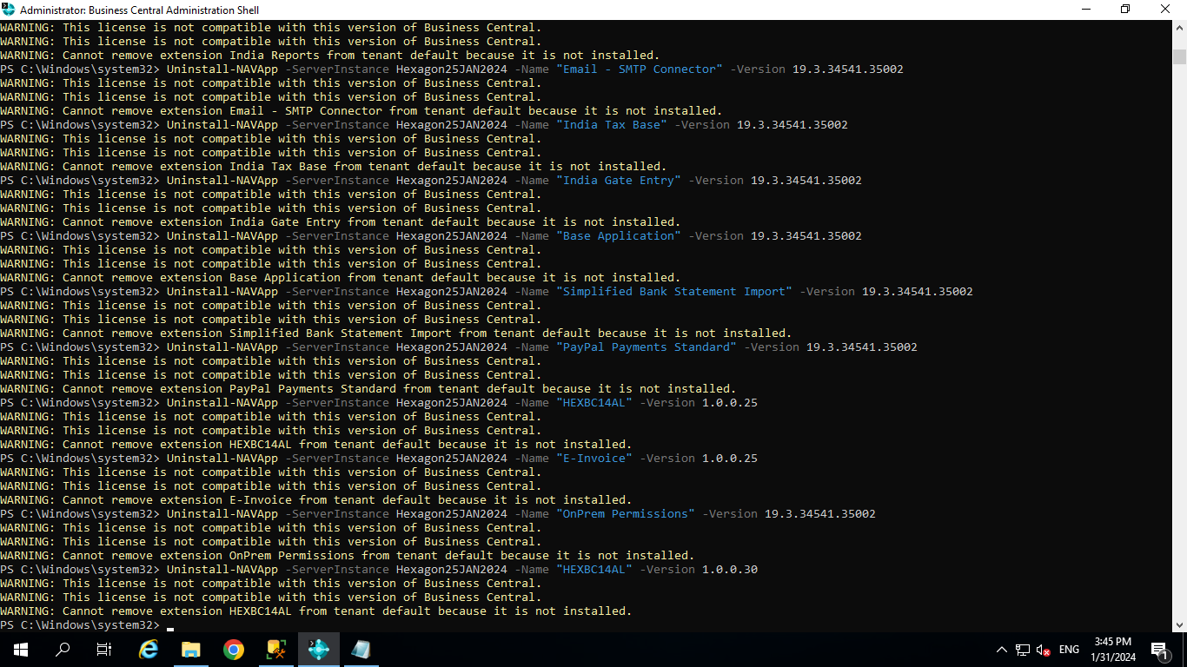

Unpublish-NAVApp -ServerInstance Hexagon25JAN2024 -Name "Designer_463db659-8aec-46d8-a729-1755d9735cbd" -Version 1.0.0.0

Unpublish-NAVApp -ServerInstance Hexagon25JAN2024 -Name "HEXBC14AL" -Version 1.0.0.30

Unpublish-NAVApp -ServerInstance Hexagon25JAN2024 -Name "E-Invoice" -Version 1.0.0.25

Unpublish-NAVApp -ServerInstance Hexagon25JAN2024 -Name "HEXBC14AL" -Version 1.0.0.25

Unpublish-NAVApp -ServerInstance Hexagon25JAN2024 -Name "India Reports" -Version 19.3.34541.35002

Unpublish-NAVApp -ServerInstance Hexagon25JAN2024 -Name "India Voucher Interface" -Version 19.3.34541.35002

Unpublish-NAVApp -ServerInstance Hexagon25JAN2024 -Name "Recommended Apps" -Version 19.3.34541.35002

Unpublish-NAVApp -ServerInstance Hexagon25JAN2024 -Name "India Gate Entry" -Version 19.3.34541.35002

Unpublish-NAVApp -ServerInstance Hexagon25JAN2024 -Name "India GST" -Version 19.3.34541.35002

Unpublish-NAVApp -ServerInstance Hexagon25JAN2024 -Name "India TCS" -Version 19.3.34541.35002

Unpublish-NAVApp -ServerInstance Hexagon25JAN2024 -Name "India TDS" -Version 19.3.34541.35002

Unpublish-NAVApp -ServerInstance Hexagon25JAN2024 -Name "India Tax Base" -Version 19.3.34541.35002

Unpublish-NAVApp -ServerInstance Hexagon25JAN2024 -Name "Tax Engine" -Version 19.3.34541.35002

Unpublish-NAVApp -ServerInstance Hexagon25JAN2024 -Name "QR Generator" -Version 19.3.34541.35002

Unpublish-NAVApp -ServerInstance Hexagon25JAN2024 -Name "Simplified Bank Statement Import" -Version 19.3.34541.35002

Unpublish-NAVApp -ServerInstance Hexagon25JAN2024 -Name "Send To Email Printer" -Version 19.3.34541.35002

Unpublish-NAVApp -ServerInstance Hexagon25JAN2024 -Name "Sales and Inventory Forecast" -Version 19.3.34541.35002

Unpublish-NAVApp -ServerInstance Hexagon25JAN2024 -Name "PayPal Payments Standard" -Version 19.3.34541.35002

Unpublish-NAVApp -ServerInstance Hexagon25JAN2024 -Name "OnPrem Permissions" -Version 19.3.34541.35002

Unpublish-NAVApp -ServerInstance Hexagon25JAN2024 -Name "Universal Print Integration" -Version 19.3.34541.35002

Unpublish-NAVApp -ServerInstance Hexagon25JAN2024 -Name "Late Payment Prediction" -Version 19.3.34541.35002

Unpublish-NAVApp -ServerInstance Hexagon25JAN2024 -Name "Fixed Asset Depreciation for India" -Version 19.3.34541.35002

Unpublish-NAVApp -ServerInstance Hexagon25JAN2024 -Name "Email - SMTP Connector" -Version 19.3.34541.35002

Unpublish-NAVApp -ServerInstance Hexagon25JAN2024 -Name "Email - Current User Connector" -Version 19.3.34541.35002

Unpublish-NAVApp -ServerInstance Hexagon25JAN2024 -Name "Email - Microsoft 365 Connector" -Version 19.3.34541.35002

Unpublish-NAVApp -ServerInstance Hexagon25JAN2024 -Name "Email - Outlook REST API" -Version 19.3.34541.35002

Unpublish-NAVApp -ServerInstance Hexagon25JAN2024 -Name "Application" -Version 19.3.34541.35002

Unpublish-NAVApp -ServerInstance Hexagon25JAN2024 -Name "Base Application" -Version 19.3.34541.35002

Unpublish-NAVApp -ServerInstance Hexagon25JAN2024 -Name "System Application" -Version 19.3.34541.35002

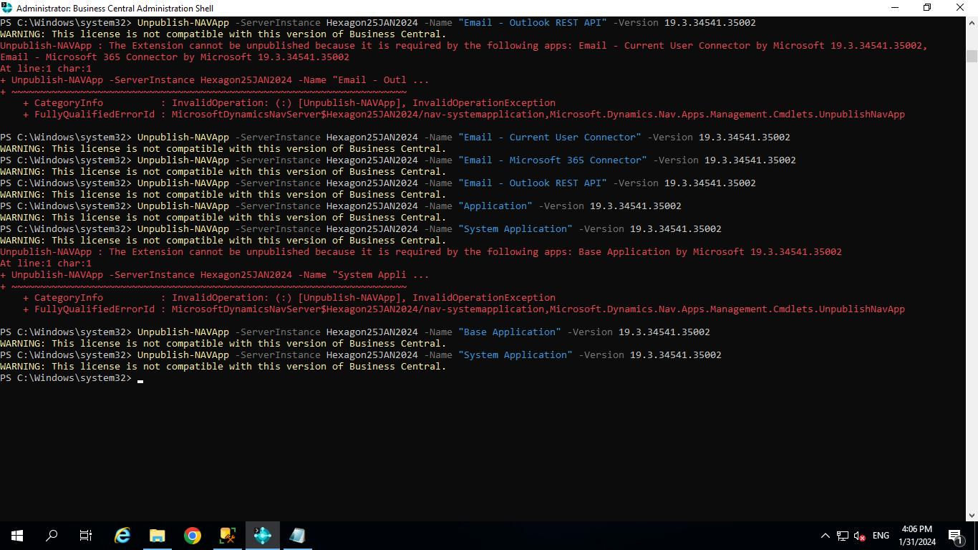

Check the Apps if Any UnInstalled Or UnPublished

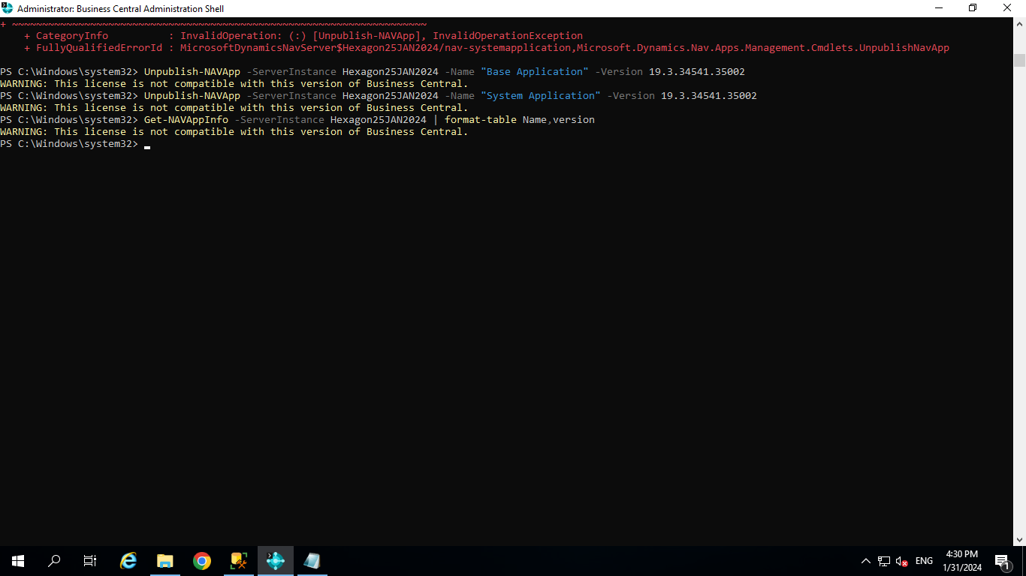

1. Stop-NAVServerInstance -ServerInstance Hexagon25JAN2024

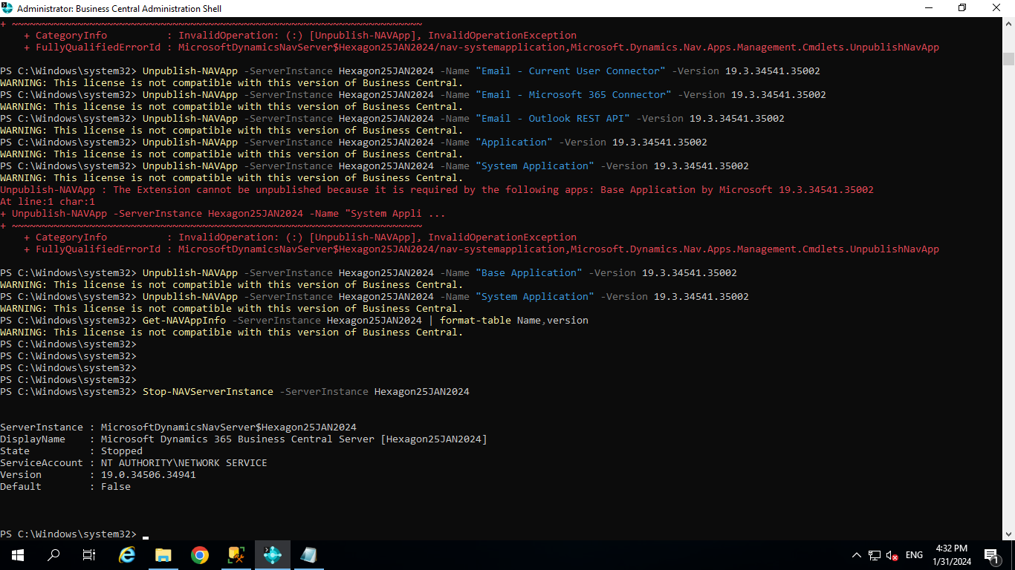

1. Database Conversion

**Open BC23.1 administration shell with run as admin**

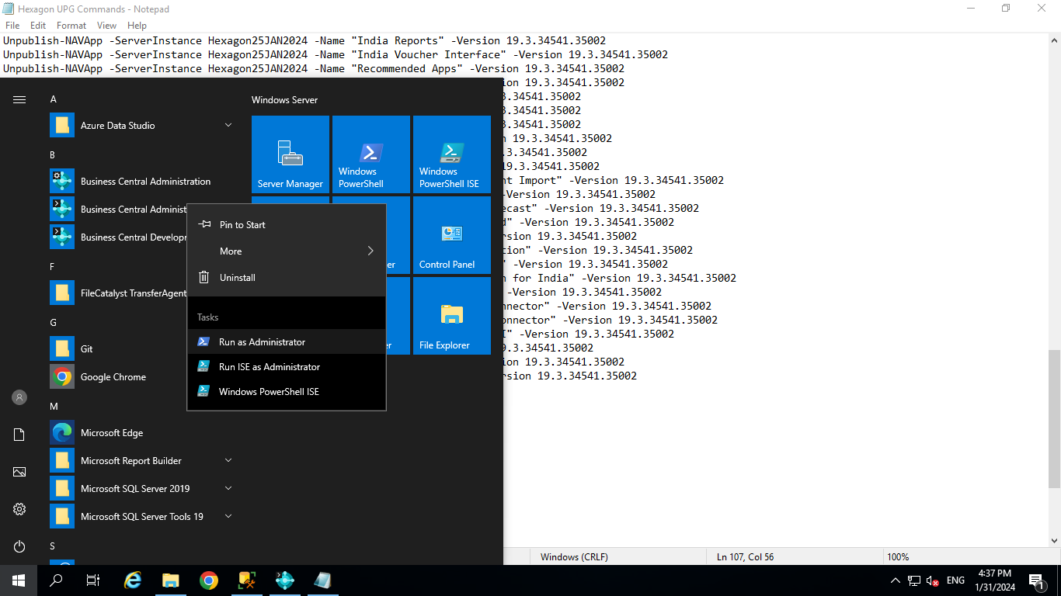

**Invoke-NAVApplicationDatabaseConversion -DatabaseServer B2BSRV-333 -DatabaseName “Hexagon25JAN2024”**

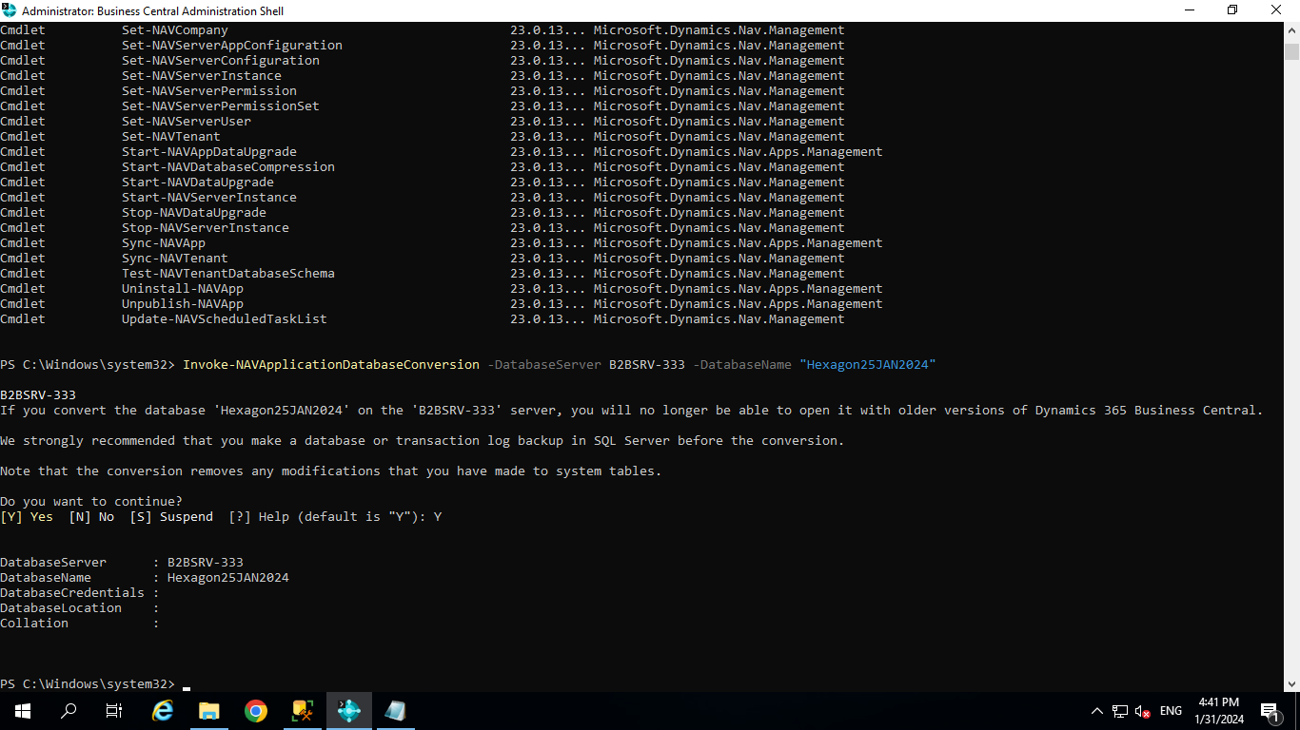

Db converted successfully.

1. Connect Database (**Hexagon25JAN2024) to BC23.1 Server Instance (BC230)**

Set-NAVServerConfiguration -serverinstance BC230 -keyname DatabaseName -keyvalue Hexagon25JAN2024

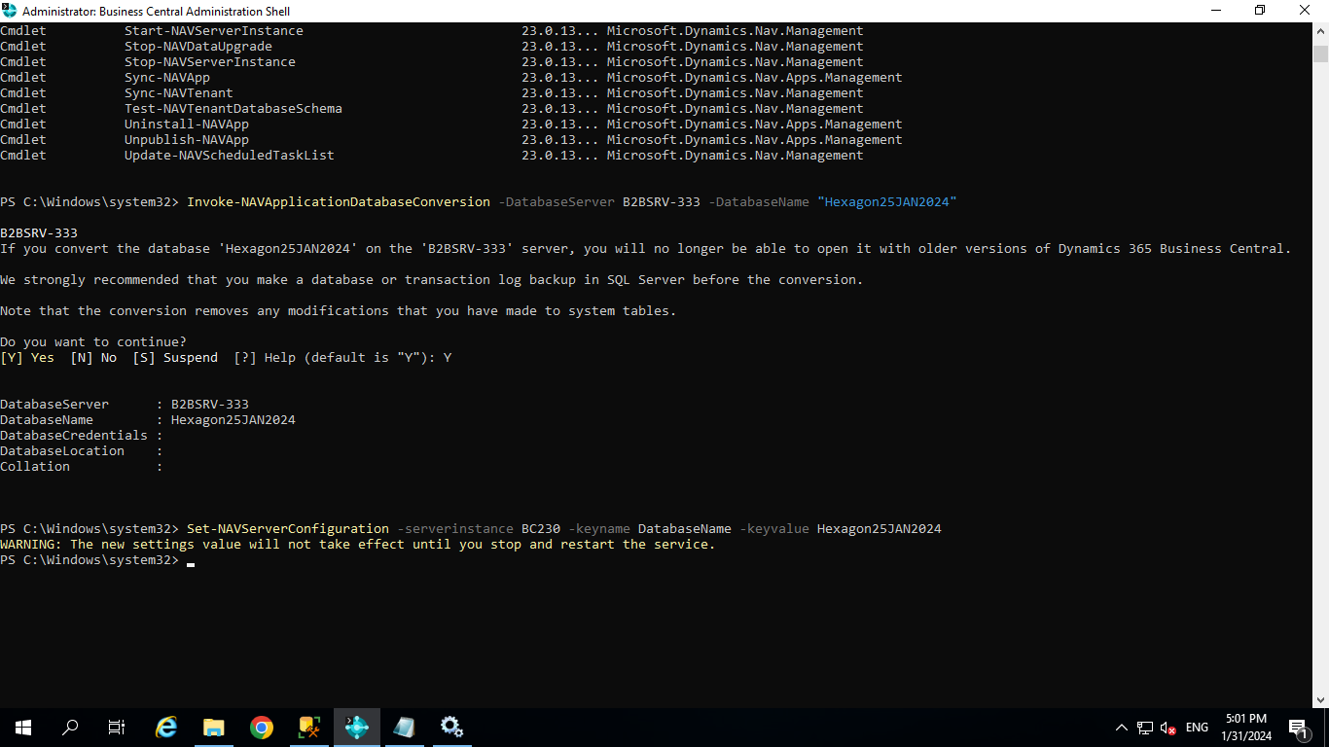

Restart the server instance.

Restart-NAVServerInstance -ServerInstance BC230

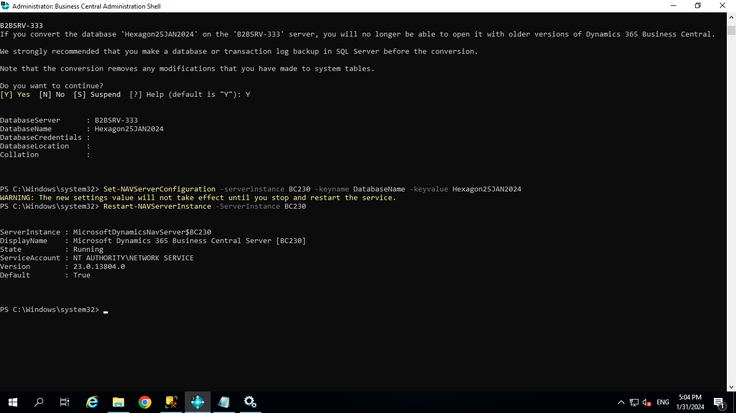

1. Disable task scheduler on the server instance for purposes of upgrade.

Set-NavServerConfiguration -ServerInstance BC230 -KeyName "EnableTaskScheduler" -KeyValue false

Restart the server instance.

Restart-NAVServerInstance -ServerInstance BC230

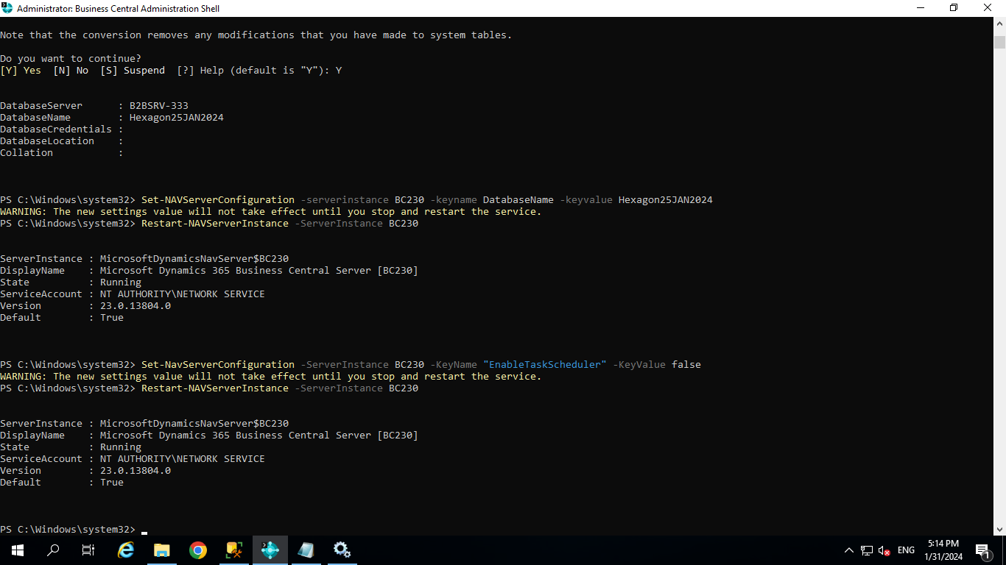

Import license

Import-NavServerLicense -ServerInstance BC230 -Licensefile "D:\License\B2B BC License.bclicense"

Restart the server instance.

Restart-NAVServerInstance -ServerInstance BC230

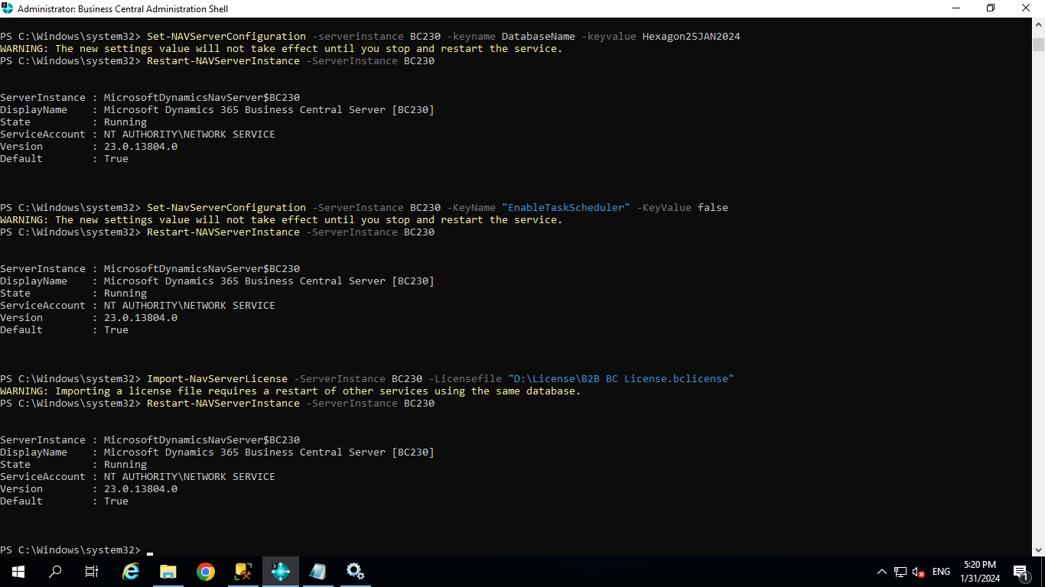

Take The SQL Backup

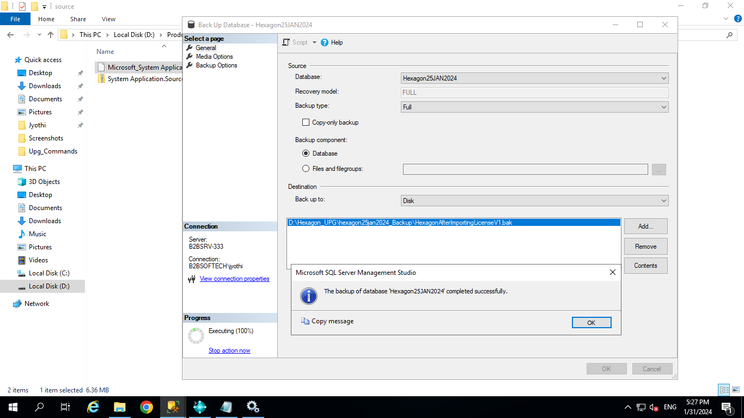

Publish-NAVApp -ServerInstance BC230 -Path “D:\Product\BC23.1IN\Dynamics.365.BC.13812.IN.DVD\Applications\system application\source\Microsoft_System Application.app”

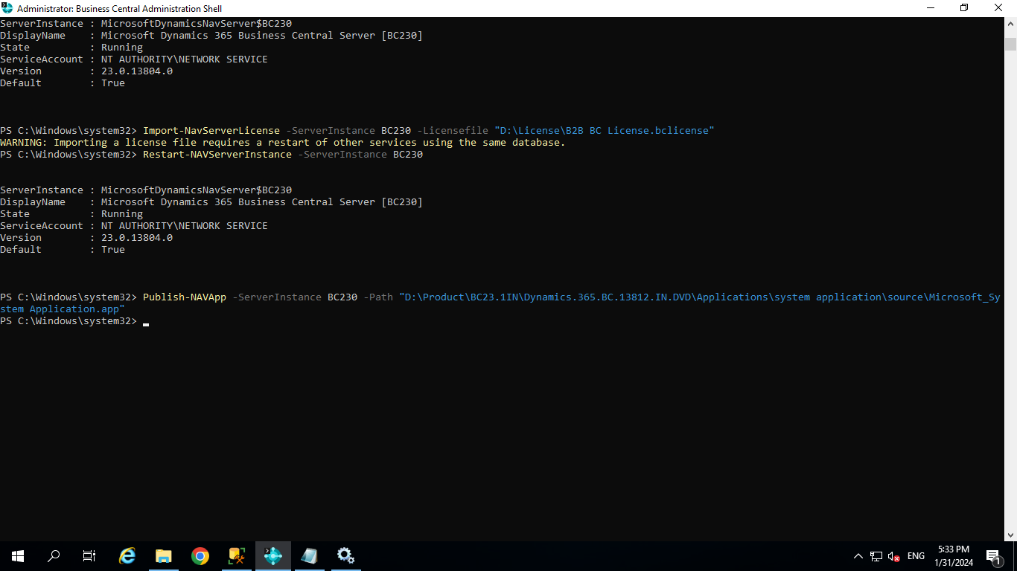

Publish-NAVApp -ServerInstance BC230 -Path “D:\Product\BC23.1IN\Dynamics.365.BC.13812.IN.DVD\Applications\BaseApp\Source\Microsoft_Base Application.app”

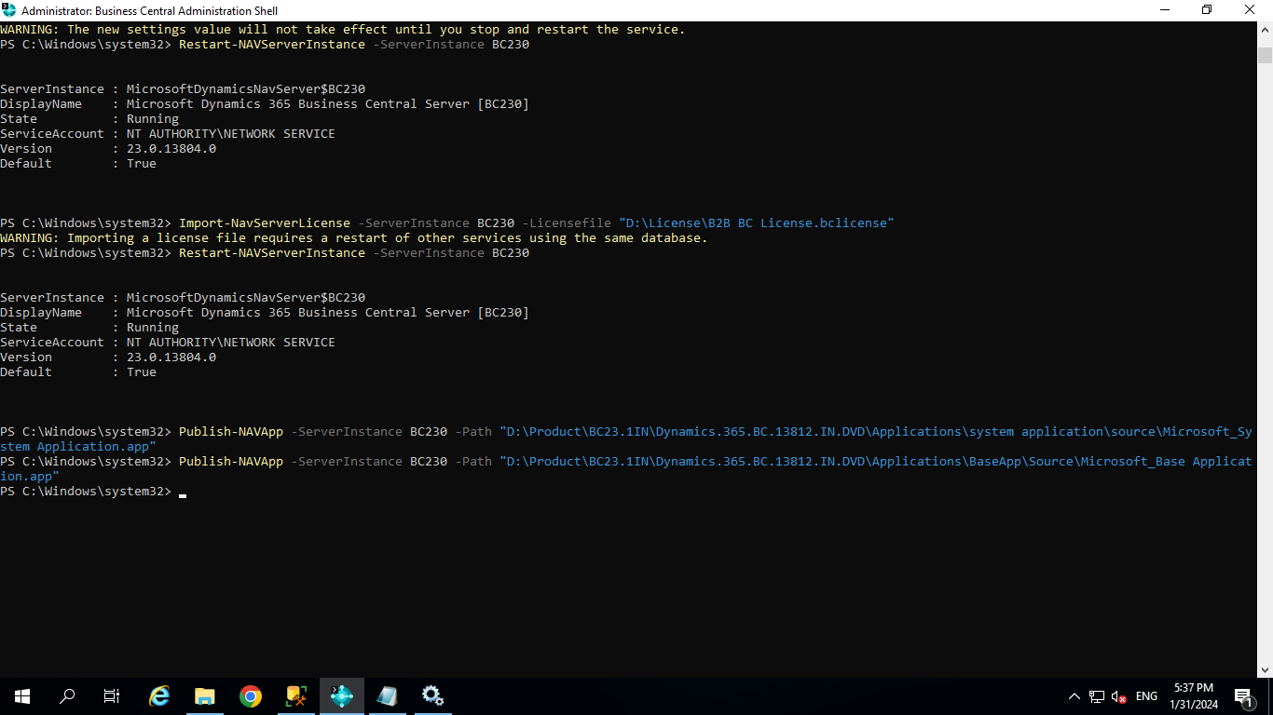

Publish-NAVApp -ServerInstance BC230 -Path “D:\Product\BC23.1IN\Dynamics.365.BC.13812.IN.DVD\Applications\Application\Source\Microsoft_Application.app”

--------------------------Remaining Apps

Publish-NAVApp -ServerInstance BC230 -Path “D:\Product\BC23.1IN\Dynamics.365.BC.13812.IN.DVD\Applications\APIReportsFinance\Source\Microsoft_API Reports - Finance.app”

Publish-NAVApp -ServerInstance BC230 -Path “D:\Product\BC23.1IN\Dynamics.365.BC.13812.IN.DVD\Applications\APIV1\Source\Microsoft__Exclude_APIV1_.app”

Publish-NAVApp -ServerInstance BC230 -Path “D:\Product\BC23.1IN\Dynamics.365.BC.13812.IN.DVD\Applications\APIV2\Source\Microsoft__Exclude_APIV2_.app”

Publish-NAVApp -ServerInstance BC230 -Path “D:\Product\BC23.1IN\Dynamics.365.BC.13812.IN.DVD\Applications\AuditFileExport\Source\Microsoft_Audit File Export.app”

Publish-NAVApp -ServerInstance BC230 -Path “D:\Product\BC23.1IN\Dynamics.365.BC.13812.IN.DVD\Applications\BankAccRecWithAI\Source\Microsoft_Bank Account Reconciliation With AI.app”

Publish-NAVApp -ServerInstance BC230 -Path “D:\Product\BC23.1IN\Dynamics.365.BC.13812.IN.DVD\Applications\BankDeposits\Source\Microsoft__Exclude_Bank Deposits.app”

Publish-NAVApp -ServerInstance BC230 -Path “D:\Product\BC23.1IN\Dynamics.365.BC.13812.IN.DVD\Applications\ClientAddIns\Source\Microsoft__Exclude_ClientAddIns_.app”

Publish-NAVApp -ServerInstance BC230 -Path “D:\Product\BC23.1IN\Dynamics.365.BC.13812.IN.DVD\Applications\CompanyHub\Source\Microsoft_Company Hub.app”

Publish-NAVApp -ServerInstance BC230 -Path “D:\Product\BC23.1IN\Dynamics.365.BC.13812.IN.DVD\Applications\ContosoCoffeeDemoDataset\Source\Microsoft_Contoso Coffee Demo Dataset.app”

Publish-NAVApp -ServerInstance BC230 -Path “D:\Product\BC23.1IN\Dynamics.365.BC.13812.IN.DVD\Applications\DataArchive\app\Microsoft_Data Archive.app”

Publish-NAVApp -ServerInstance BC230 -Path “D:\Product\BC23.1IN\Dynamics.365.BC.13812.IN.DVD\Applications\datacorrectionfa\source\Microsoft_Troubleshoot FA Ledger Entries.app”

Publish-NAVApp -ServerInstance BC230 -Path “D:\Product\BC23.1IN\Dynamics.365.BC.13812.IN.DVD\Applications\DataSearch\app\Microsoft_Data Search.app”

Publish-NAVApp -ServerInstance BC230 -Path “D:\Product\BC23.1IN\Dynamics.365.BC.13812.IN.DVD\Applications\EDocument\Source\Microsoft_E-Document Core.app”

Publish-NAVApp -ServerInstance BC230 -Path “D:\Product\BC23.1IN\Dynamics.365.BC.13812.IN.DVD\Applications\Email - Outlook REST API\Source\Microsoft_Email - Outlook REST API.app”

Publish-NAVApp -ServerInstance BC230 -Path “D:\Product\BC23.1IN\Dynamics.365.BC.13812.IN.DVD\Applications\Email - Current User Connector\Source\Microsoft_Email - Current User Connector.app”

Publish-NAVApp -ServerInstance BC230 -Path “D:\Product\BC23.1IN\Dynamics.365.BC.13812.IN.DVD\Applications\Email - Microsoft 365 Connector\Source\Microsoft_Email - Microsoft 365 Connector.app”

Publish-NAVApp -ServerInstance BC230 -Path “D:\Product\BC23.1IN\Dynamics.365.BC.13812.IN.DVD\Applications\Email - SMTP API\Source\Microsoft_Email - SMTP API.app”

Publish-NAVApp -ServerInstance BC230 -Path “D:\Product\BC23.1IN\Dynamics.365.BC.13812.IN.DVD\Applications\Email - SMTP Connector\Source\Microsoft_Email - SMTP Connector.app”

Publish-NAVApp -ServerInstance BC230 -Path “D:\Product\BC23.1IN\Dynamics.365.BC.13812.IN.DVD\Applications\EmailLogging\Source\Microsoft__Exclude_Email Logging Using Graph API.app”

Publish-NAVApp -ServerInstance BC230 -Path “D:\Product\BC23.1IN\Dynamics.365.BC.13812.IN.DVD\Applications\ErrorMessagesWithRecommendations\app\Microsoft_Error Messages with Recommendations.app”

Publish-NAVApp -ServerInstance BC230 -Path “D:\Product\BC23.1IN\Dynamics.365.BC.13812.IN.DVD\Applications\EssentialBusinessHeadlines\Source\Microsoft_Essential Business Headlines.app”

Publish-NAVApp -ServerInstance BC230 -Path “D:\Product\BC23.1IN\Dynamics.365.BC.13812.IN.DVD\Applications\ExternalEvents\Source\Microsoft__Exclude_Business_Events_.app”

Publish-NAVApp -ServerInstance BC230 -Path “D:\Product\BC23.1IN\Dynamics.365.BC.13812.IN.DVD\Applications\INTaxEngine\Source\Microsoft_Tax Engine.app”

Publish-NAVApp -ServerInstance BC230 -Path “D:\Product\BC23.1IN\Dynamics.365.BC.13812.IN.DVD\Applications\INTaxBase\Source\Microsoft_India Tax Base.app”

Publish-NAVApp -ServerInstance BC230 -Path “D:\Product\BC23.1IN\Dynamics.365.BC.13812.IN.DVD\Applications\INChargeGroup\Source\Microsoft_India Charge Group.app”

Publish-NAVApp -ServerInstance BC230 -Path “D:\Product\BC23.1IN\Dynamics.365.BC.13812.IN.DVD\Applications\QRGeneration\Source\Microsoft_QR Generator.app”

Publish-NAVApp -ServerInstance BC230 -Path “D:\Product\BC23.1IN\Dynamics.365.BC.13812.IN.DVD\Applications\INGST\Source\Microsoft_India GST.app”

Publish-NAVApp -ServerInstance BC230 -Path “D:\Product\BC23.1IN\Dynamics.365.BC.13812.IN.DVD\Applications\INTCS\Source\Microsoft_India TCS.app”

Publish-NAVApp -ServerInstance BC230 -Path “D:\Product\BC23.1IN\Dynamics.365.BC.13812.IN.DVD\Applications\INTDS\Source\Microsoft_India TDS.app”

Publish-NAVApp -ServerInstance BC230 -Path “D:\Product\BC23.1IN\Dynamics.365.BC.13812.IN.DVD\Applications\INDataMigration\Source\Microsoft_India Data Migration.app”

Publish-NAVApp -ServerInstance BC230 -Path “D:\Product\BC23.1IN\Dynamics.365.BC.13812.IN.DVD\Applications\INFADepreciation\Source\Microsoft_Fixed Asset Depreciation for India.app”

Publish-NAVApp -ServerInstance BC230 -Path “D:\Product\BC23.1IN\Dynamics.365.BC.13812.IN.DVD\Applications\INGateEntry\Source\Microsoft_India Gate Entry.app”

Publish-NAVApp -ServerInstance BC230 -Path “D:\Product\BC23.1IN\Dynamics.365.BC.13812.IN.DVD\Applications\INVoucherInterface\Source\Microsoft_India Voucher Interface.app”

Publish-NAVApp -ServerInstance BC230 -Path “D:\Product\BC23.1IN\Dynamics.365.BC.13812.IN.DVD\Applications\INReports\Source\Microsoft_India Reports.app”

Publish-NAVApp -ServerInstance BC230 -Path “D:\Product\BC23.1IN\Dynamics.365.BC.13812.IN.DVD\Applications\LatePaymentPredictor\Source\Microsoft_Late Payment Prediction.app”

Publish-NAVApp -ServerInstance BC230 -Path “D:\Product\BC23.1IN\Dynamics.365.BC.13812.IN.DVD\Applications\MasterDataManagement\Source\Microsoft__Exclude_Master_Data_Management.app”

Publish-NAVApp -ServerInstance BC230 -Path “D:\Product\BC23.1IN\Dynamics.365.BC.13812.IN.DVD\Applications\microsoftuniversalprint\source\Microsoft_Universal Print Integration.app”

Publish-NAVApp -ServerInstance BC230 -Path “D:\Product\BC23.1IN\Dynamics.365.BC.13812.IN.DVD\Applications\onprem permissions\source\Microsoft_OnPrem Permissions.app”

Publish-NAVApp -ServerInstance BC230 -Path “D:\Product\BC23.1IN\Dynamics.365.BC.13812.IN.DVD\Applications\paymentpractices\source\Microsoft_Payment Practices.app”

Publish-NAVApp -ServerInstance BC230 -Path “D:\Product\BC23.1IN\Dynamics.365.BC.13812.IN.DVD\Applications\paypalpaymentsstandard\source\Microsoft_Payment Links to PayPal.app”

Publish-NAVApp -ServerInstance BC230 -Path “D:\Product\BC23.1IN\Dynamics.365.BC.13812.IN.DVD\Applications\PlanConfiguration\Source\Microsoft__Exclude_PlanConfiguration_.app”

Publish-NAVApp -ServerInstance BC230 -Path “D:\Product\BC23.1IN\Dynamics.365.BC.13812.IN.DVD\Applications\recommendedapps\source\Microsoft_Recommended Apps.app”

Publish-NAVApp -ServerInstance BC230 -Path “D:\Product\BC23.1IN\Dynamics.365.BC.13812.IN.DVD\Applications\ReportLayouts\Source\Microsoft__Exclude_ReportLayouts.app”

Publish-NAVApp -ServerInstance BC230 -Path “D:\Product\BC23.1IN\Dynamics.365.BC.13812.IN.DVD\Applications\reviewglentries\source\Microsoft_Review General Ledger Entries.app”

Publish-NAVApp -ServerInstance BC230 -Path “D:\Product\BC23.1IN\Dynamics.365.BC.13812.IN.DVD\Applications\salesandinventoryforecast\source\Microsoft_Sales and Inventory Forecast.app”

Publish-NAVApp -ServerInstance BC230 -Path “D:\Product\BC23.1IN\Dynamics.365.BC.13812.IN.DVD\Applications\sendtoemailprinter\source\Microsoft_Send To Email Printer.app”

Publish-NAVApp -ServerInstance BC230 -Path “D:\Product\BC23.1IN\Dynamics.365.BC.13812.IN.DVD\Applications\shopify\app\Microsoft_Shopify Connector.app”

Publish-NAVApp -ServerInstance BC230 -Path “D:\Product\BC23.1IN\Dynamics.365.BC.13812.IN.DVD\Applications\simplifiedbankstatementimport\source\Microsoft_Simplified Bank Statement Import.app”

Publish-NAVApp -ServerInstance BC230 -Path “D:\Product\BC23.1IN\Dynamics.365.BC.13812.IN.DVD\Applications\statisticalaccounts\source\Microsoft_Statistical Accounts.app”

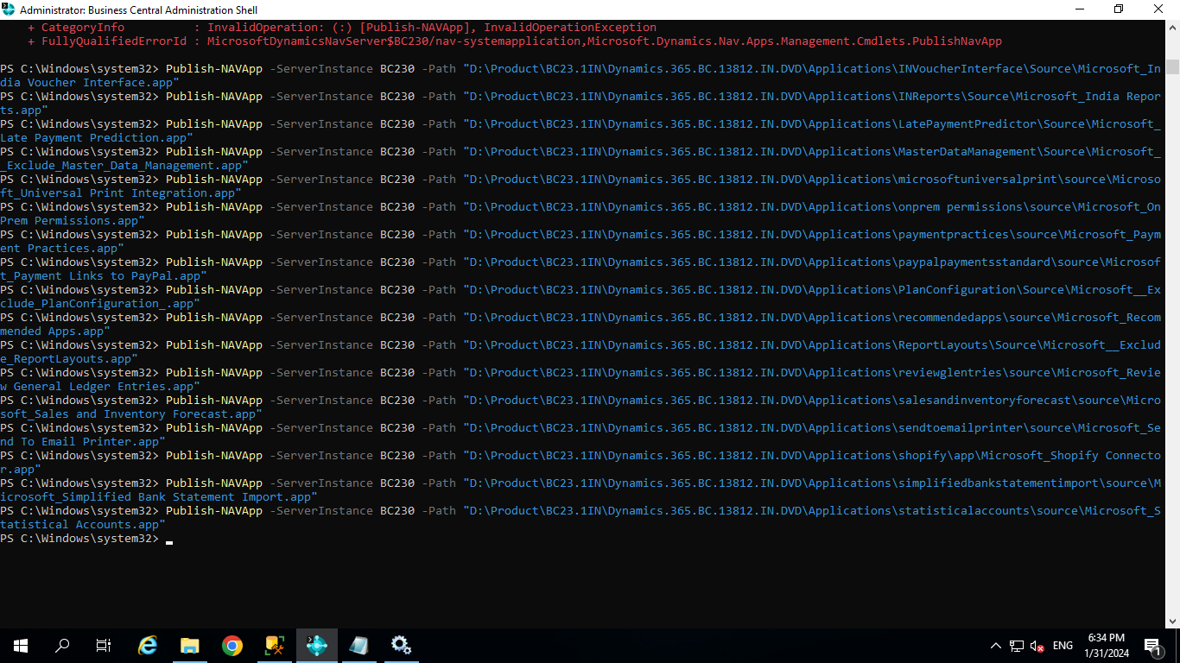

Take SQL Backup

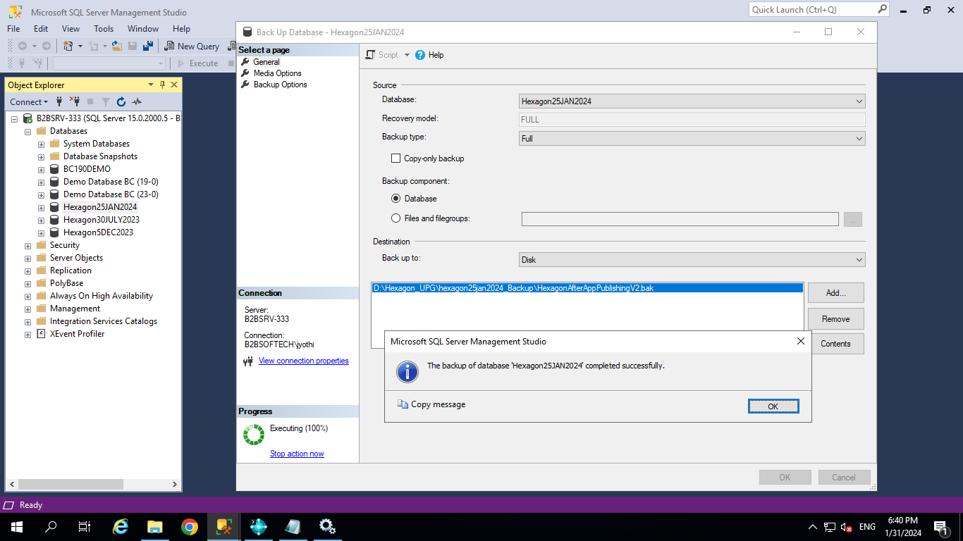

Get-NAVAppInfo -ServerInstance BC230 | format-table Name,version

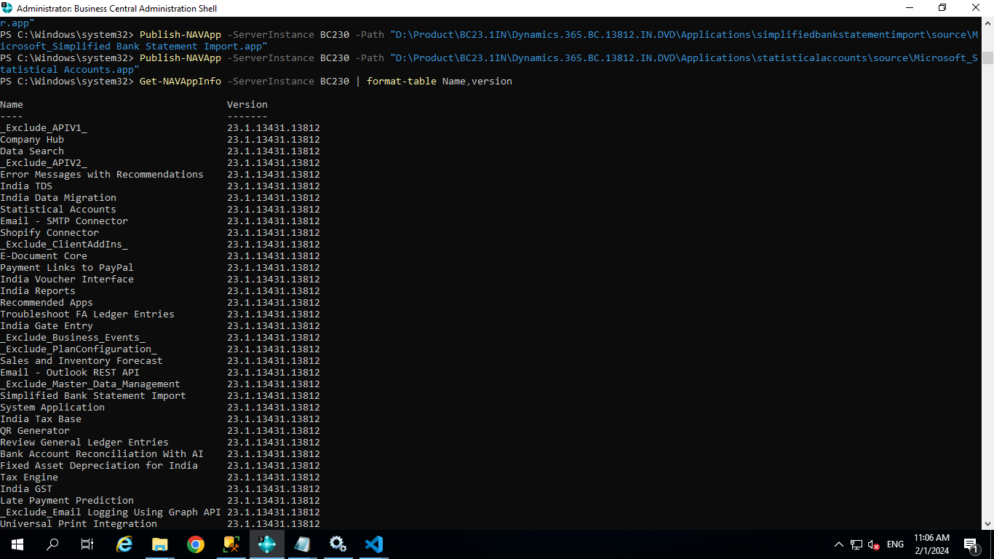

Done with apps publish

1. Sync

Sync-NAVTenant -ServerInstance BC230 -Tenant default -Mode Sync

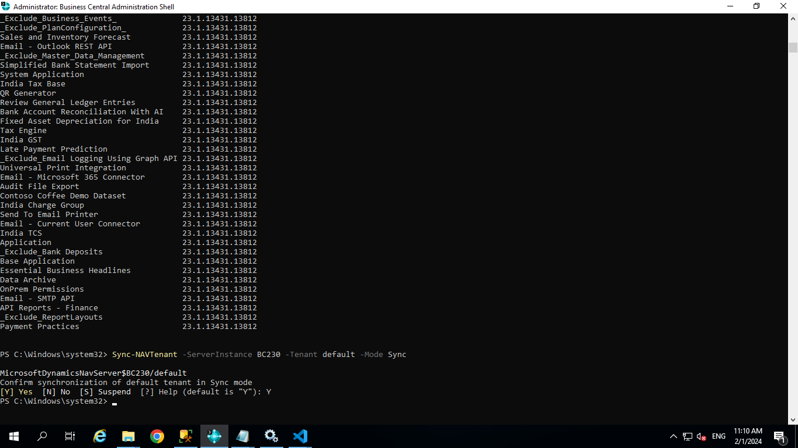

Sync-NAVApp -ServerInstance BC230 -Name "System Application" -Version "23.1.13431.13812"

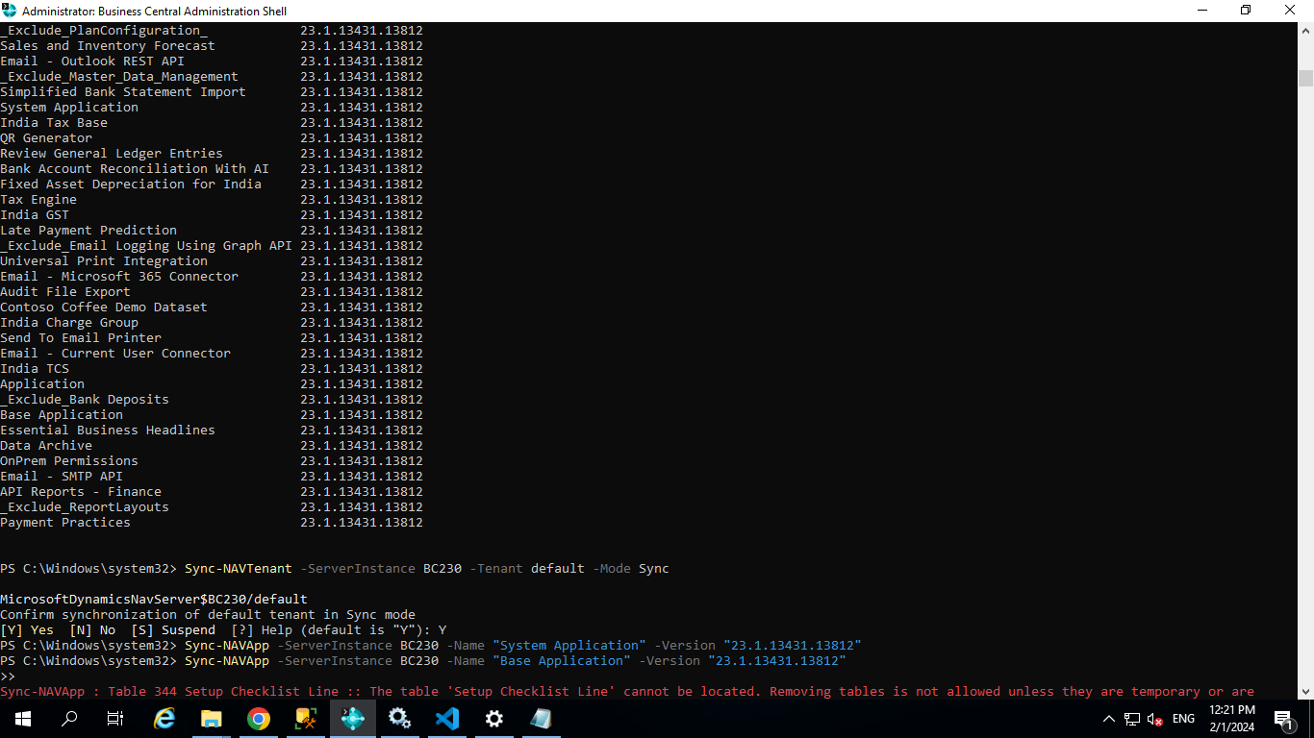

**Sync-NAVApp -ServerInstance BC230 -Name "Base Application" -Version "23.1.13431.13812"**

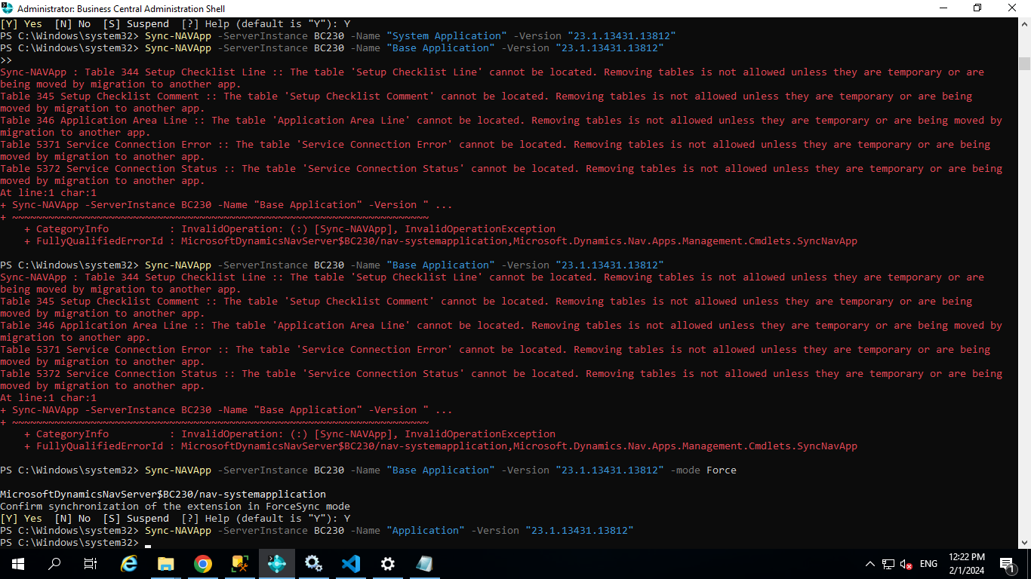

**Getting Errors As The tables mentioned in below image are not found as these tables are removed in higher versions we publish the same command for base application by using Forcesync**

**Sync-NAVApp -ServerInstance BC230 -Name "Base Application" -Version "23.1.13431.13812" -mode Force**

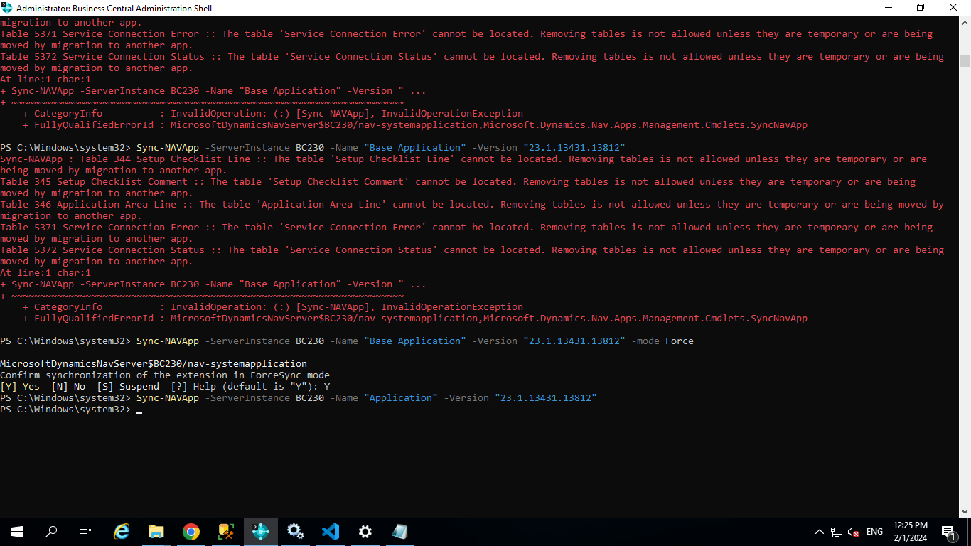

----------------------Remaining Apps

Sync-NAVApp -ServerInstance BC230 -Name "_Exclude_APIV1_" -Version "23.1.13431.13812"

Sync-NAVApp -ServerInstance BC230 -Name "Company Hub" -Version "23.1.13431.13812"

Sync-NAVApp -ServerInstance BC230 -Name "Data Search" -Version "23.1.13431.13812"

Sync-NAVApp -ServerInstance BC230 -Name "_Exclude_APIV2_" -Version "23.1.13431.13812"

Sync-NAVApp -ServerInstance BC230 -Name "Error Messages with Recommendations" -Version "23.1.13431.13812"

Sync-NAVApp -ServerInstance BC230 -Name "Tax Engine" -Version "23.1.13431.13812"

Sync-NAVApp -ServerInstance BC230 -Name "India Tax Base" -Version "23.1.13431.13812"

Sync-NAVApp -ServerInstance BC230 -Name "India TDS" -Version "23.1.13431.13812"

Sync-NAVApp -ServerInstance BC230 -Name "QR Generator" -Version "23.1.13431.13812"

Sync-NAVApp -ServerInstance BC230 -Name "India GST" -Version "23.1.13431.13812"

Sync-NAVApp -ServerInstance BC230 -Name "India TCS" -Version "23.1.13431.13812"

Sync-NAVApp -ServerInstance BC230 -Name "India Data Migration" -Version "23.1.13431.13812"

Sync-NAVApp -ServerInstance BC230 -Name "Statistical Accounts" -Version "23.1.13431.13812"

Sync-NAVApp -ServerInstance BC230 -Name "Email - SMTP API" -Version "23.1.13431.13812"

Sync-NAVApp -ServerInstance BC230 -Name "Email - SMTP Connector" -Version "23.1.13431.13812"

Sync-NAVApp -ServerInstance BC230 -Name "Shopify Connector" -Version "23.1.13431.13812"

Sync-NAVApp -ServerInstance BC230 -Name "_Exclude_ClientAddIns_" -Version "23.1.13431.13812"

Sync-NAVApp -ServerInstance BC230 -Name "E-Document Core" -Version "23.1.13431.13812"

Sync-NAVApp -ServerInstance BC230 -Name "Payment Links to PayPal" -Version "23.1.13431.13812"

Sync-NAVApp -ServerInstance BC230 -Name "India Voucher Interface" -Version "23.1.13431.13812"

Sync-NAVApp -ServerInstance BC230 -Name "India Reports" -Version "23.1.13431.13812"

Sync-NAVApp -ServerInstance BC230 -Name "Recommended Apps" -Version "23.1.13431.13812"

Sync-NAVApp -ServerInstance BC230 -Name "Troubleshoot FA Ledger Entries" -Version "23.1.13431.13812"

Sync-NAVApp -ServerInstance BC230 -Name "India Gate Entry" -Version "23.1.13431.13812"

Sync-NAVApp -ServerInstance BC230 -Name "_Exclude_Business_Events_" -Version "23.1.13431.13812"

Sync-NAVApp -ServerInstance BC230 -Name "_Exclude_PlanConfiguration_" -Version "23.1.13431.13812"

Sync-NAVApp -ServerInstance BC230 -Name "Sales and Inventory Forecast" -Version "23.1.13431.13812"

Sync-NAVApp -ServerInstance BC230 -Name "Email - Outlook REST API" -Version "23.1.13431.13812"

Sync-NAVApp -ServerInstance BC230 -Name "_Exclude_Master_Data_Management" -Version "23.1.13431.13812"

Sync-NAVApp -ServerInstance BC230 -Name "Simplified Bank Statement Import" -Version "23.1.13431.13812"

Sync-NAVApp -ServerInstance BC230 -Name "Review General Ledger Entries" -Version "23.1.13431.13812"

Sync-NAVApp -ServerInstance BC230 -Name "Bank Account Reconciliation With AI" -Version "23.1.13431.13812"

Sync-NAVApp -ServerInstance BC230 -Name "Fixed Asset Depreciation for India" -Version "23.1.13431.13812"

Sync-NAVApp -ServerInstance BC230 -Name "Late Payment Prediction" -Version "23.1.13431.13812"

Sync-NAVApp -ServerInstance BC230 -Name "_Exclude_Email Logging Using Graph API" -Version "23.1.13431.13812"

Sync-NAVApp -ServerInstance BC230 -Name "Universal Print Integration" -Version "23.1.13431.13812"

Sync-NAVApp -ServerInstance BC230 -Name "Email - Microsoft 365 Connector" -Version "23.1.13431.13812"

Sync-NAVApp -ServerInstance BC230 -Name "Audit File Export" -Version "23.1.13431.13812"

Sync-NAVApp -ServerInstance BC230 -Name "Contoso Coffee Demo Dataset" -Version "23.1.13431.13812"

Sync-NAVApp -ServerInstance BC230 -Name "India Charge Group" -Version "23.1.13431.13812"

Sync-NAVApp -ServerInstance BC230 -Name "Send To Email Printer" -Version "23.1.13431.13812"

Sync-NAVApp -ServerInstance BC230 -Name "Email - Current User Connector" -Version "23.1.13431.13812"

Sync-NAVApp -ServerInstance BC230 -Name "_Exclude_Bank Deposits" -Version "23.1.13431.13812"

Sync-NAVApp -ServerInstance BC230 -Name "Essential Business Headlines" -Version "23.1.13431.13812"

Sync-NAVApp -ServerInstance BC230 -Name "Data Archive" -Version "23.1.13431.13812"

Sync-NAVApp -ServerInstance BC230 -Name "OnPrem Permissions" -Version "23.1.13431.13812"

Sync-NAVApp -ServerInstance BC230 -Name "API Reports - Finance" -Version "23.1.13431.13812"

Sync-NAVApp -ServerInstance BC230 -Name "_Exclude_ReportLayouts" -Version "23.1.13431.13812"

Sync-NAVApp -ServerInstance BC230 -Name "Payment Practices" -Version "23.1.13431.13812"

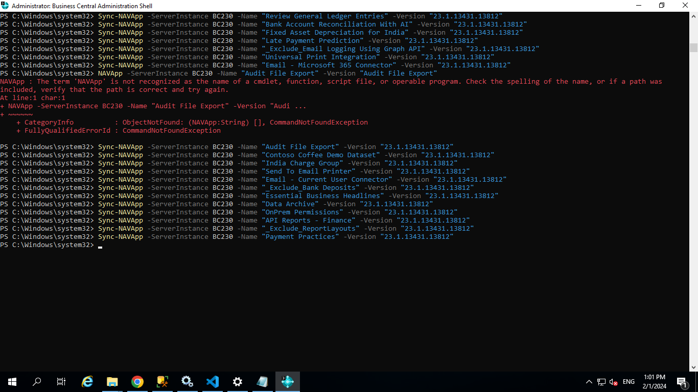

Sync done successfully

Take SQL Backup

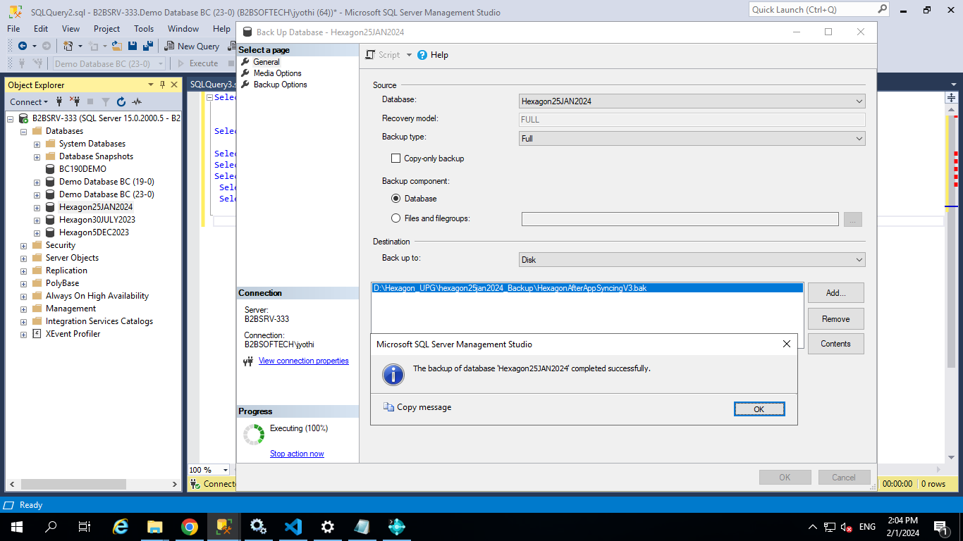

Check application version

Get-NAVApplication -ServerInstance BC230

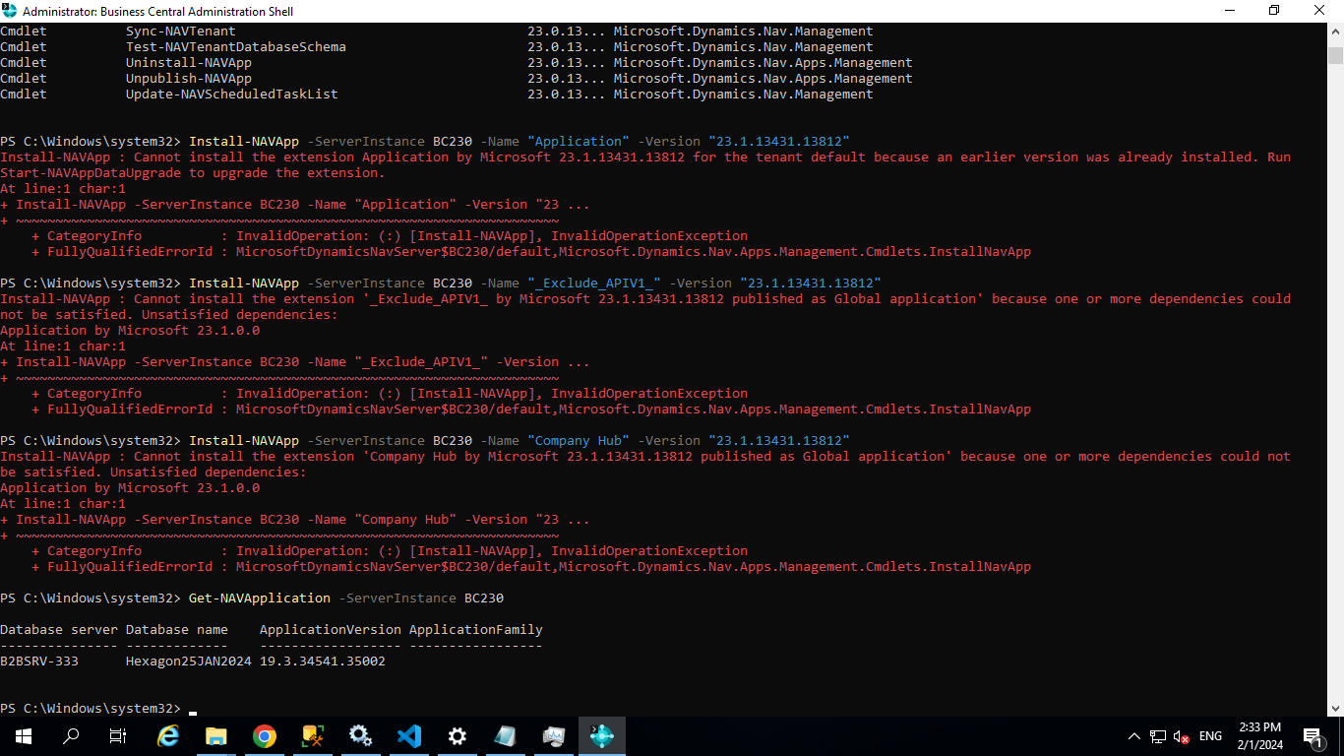

In above, application is still in 19 version. Change it to BC23.1 version using below command

Set-NAVApplication -ServerInstance BC230 -ApplicationVersion 23.1.13431.13812 -Force

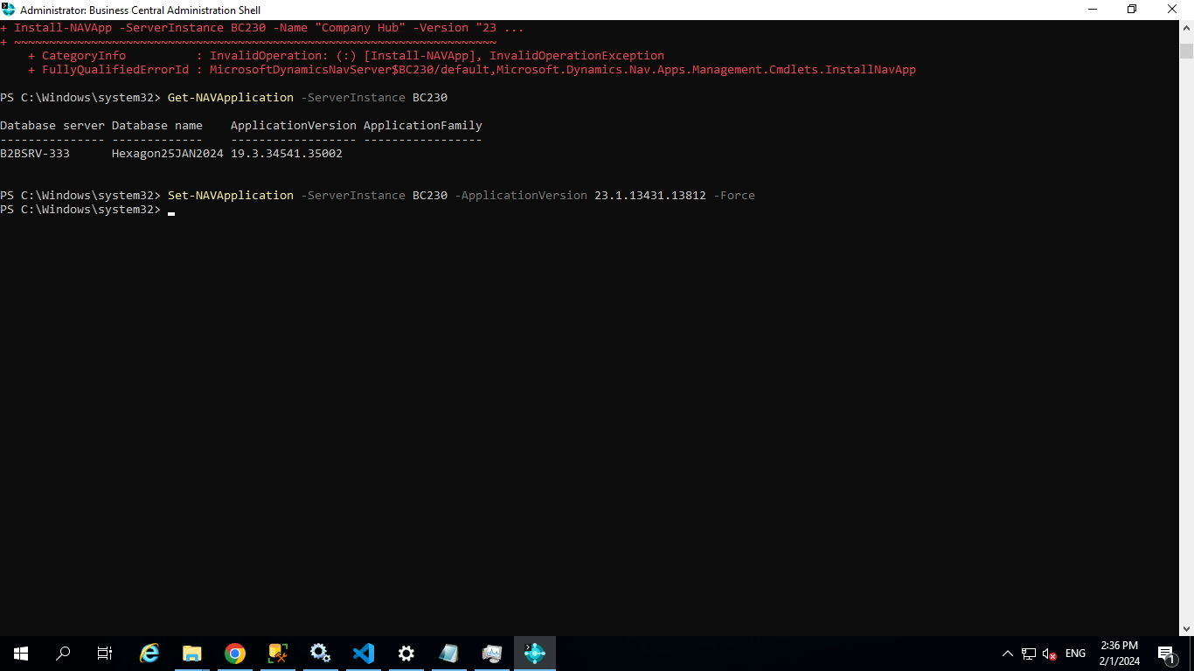

Once Check application version

Get-NAVApplication -ServerInstance BC230

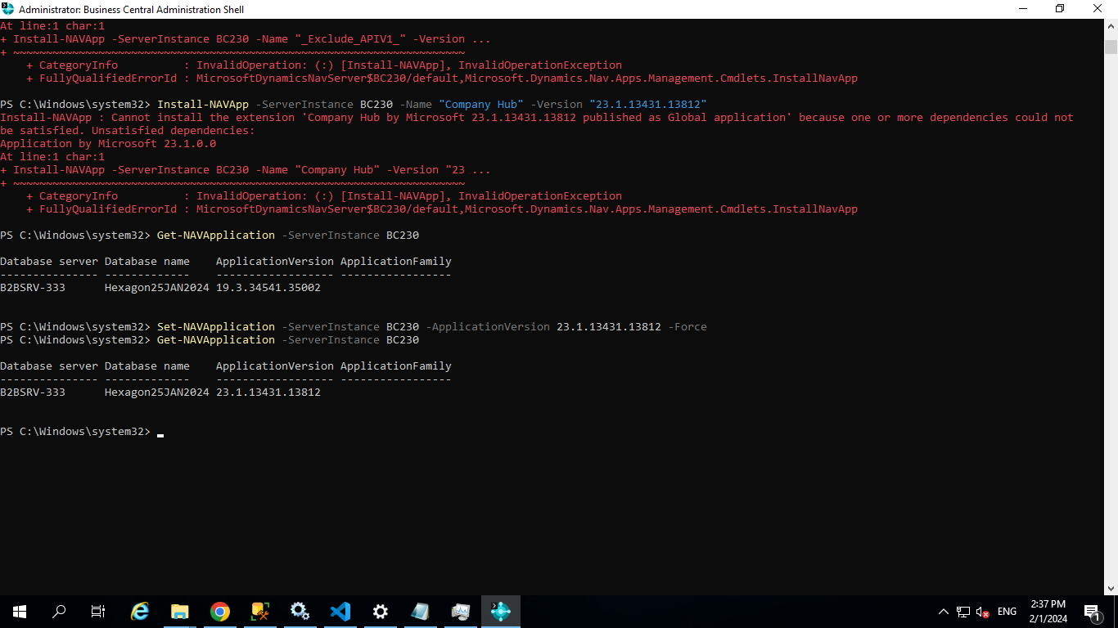

Once sync

Sync-NAVTenant -ServerInstance BC230 -Mode Sync

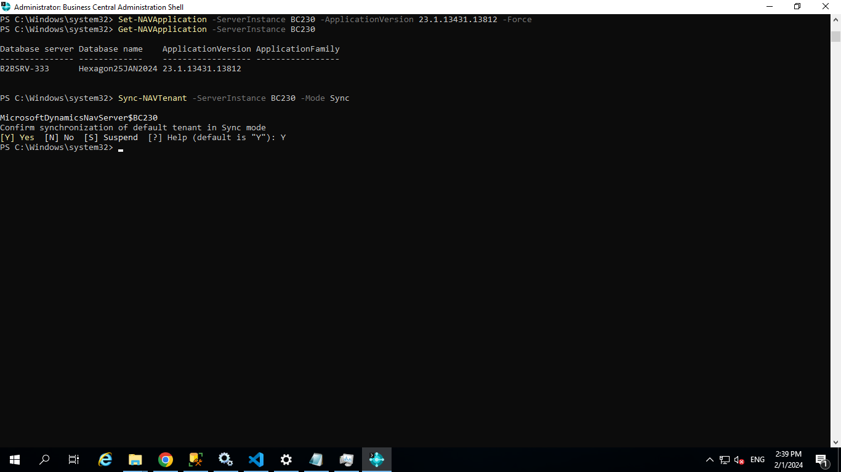

Restart serverInstance

Restart-NAVServerInstance -ServerInstance BC230

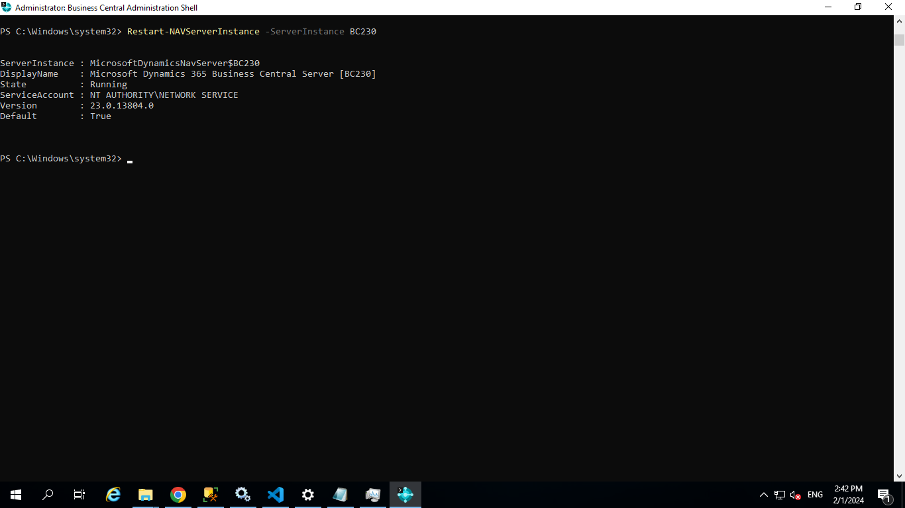

Start upgrade using below command

Start-NavDataUpgrade -ServerInstance BC230

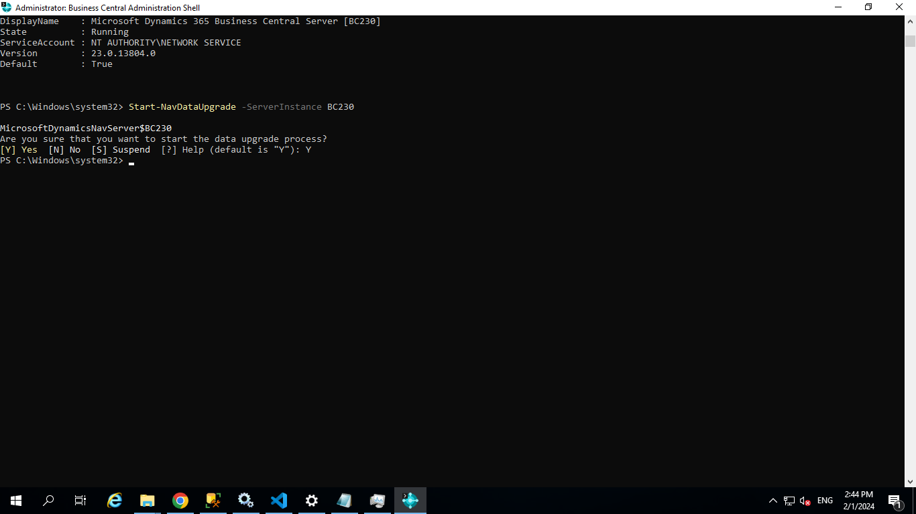

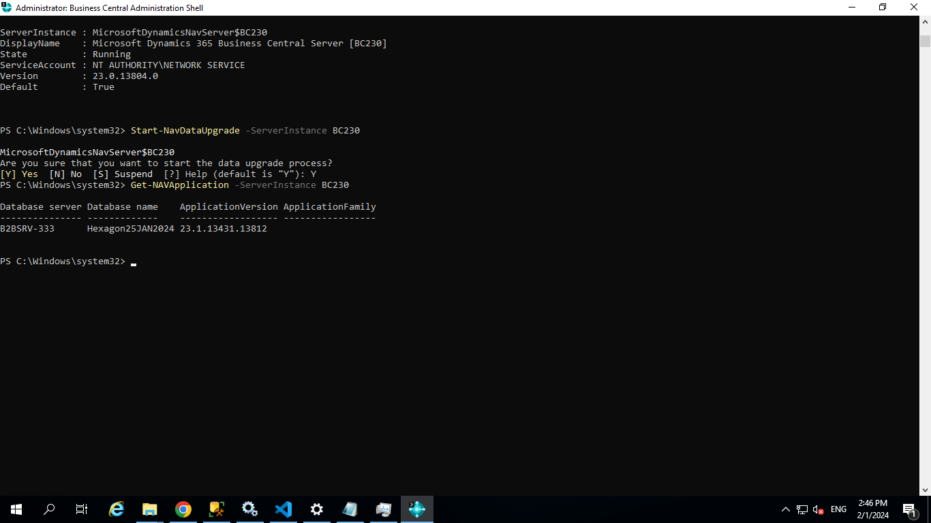

Take SQL Backup

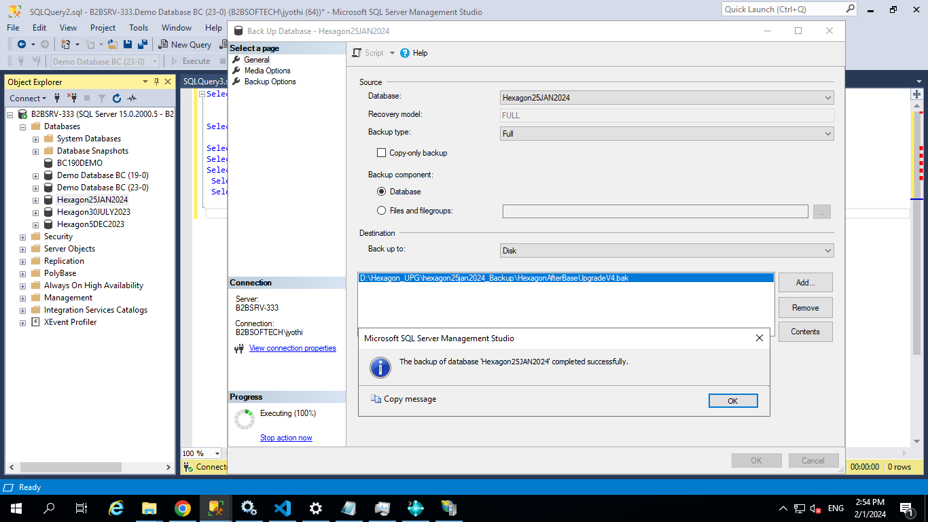

----------------Installing Apps

Start-NAVAppDataUpgrade -ServerInstance BC230 -Name "System Application" -Version "23.1.13431.13812"

Start-NAVAppDataUpgrade -ServerInstance BC230 -Name "Base Application" -Version "23.1.13431.13812"

Start-NAVAppDataUpgrade -ServerInstance BC230 -Name "Application" -Version "23.1.13431.13812"

----------------------Remaining Apps

Start-NAVAppDataUpgrade -ServerInstance BC230 -Name "_Exclude_APIV1_" -Version "23.1.13431.13812"

Start-NAVAppDataUpgrade -ServerInstance BC230 -Name "Company Hub" -Version "23.1.13431.13812"

Start-NAVAppDataUpgrade -ServerInstance BC230 -Name "Data Search" -Version "23.1.13431.13812"

Start-NAVAppDataUpgrade -ServerInstance BC230 -Name "_Exclude_APIV2_" -Version "23.1.13431.13812"

Start-NAVAppDataUpgrade -ServerInstance BC230 -Name "Error Messages with Recommendations" -Version "23.1.13431.13812"

Start-NAVAppDataUpgrade -ServerInstance BC230 -Name "Tax Engine" -Version "23.1.13431.13812"

Start-NAVAppDataUpgrade -ServerInstance BC230 -Name "India Tax Base" -Version "23.1.13431.13812"

Start-NAVAppDataUpgrade -ServerInstance BC230 -Name "India TDS" -Version "23.1.13431.13812"

Start-NAVAppDataUpgrade -ServerInstance BC230 -Name "QR Generator" -Version "23.1.13431.13812"

Start-NAVAppDataUpgrade -ServerInstance BC230 -Name "India GST" -Version "23.1.13431.13812"

Start-NAVAppDataUpgrade -ServerInstance BC230 -Name "India TCS" -Version "23.1.13431.13812"

Start-NAVAppDataUpgrade -ServerInstance BC230 -Name "India Data Migration" -Version "23.1.13431.13812"

Start-NAVAppDataUpgrade -ServerInstance BC230 -Name "Statistical Accounts" -Version "23.1.13431.13812"

Start-NAVAppDataUpgrade -ServerInstance BC230 -Name "Email - SMTP API" -Version "23.1.13431.13812"

Start-NAVAppDataUpgrade -ServerInstance BC230 -Name "Email - SMTP Connector" -Version "23.1.13431.13812"

Start-NAVAppDataUpgrade -ServerInstance BC230 -Name "Shopify Connector" -Version "23.1.13431.13812"

Start-NAVAppDataUpgrade -ServerInstance BC230 -Name "_Exclude_ClientAddIns_" -Version "23.1.13431.13812"

Start-NAVAppDataUpgrade -ServerInstance BC230 -Name "E-Document Core" -Version "23.1.13431.13812"

Start-NAVAppDataUpgrade -ServerInstance BC230 -Name "Payment Links to PayPal" -Version "23.1.13431.13812"

Start-NAVAppDataUpgrade -ServerInstance BC230 -Name "India Voucher Interface" -Version "23.1.13431.13812"

Start-NAVAppDataUpgrade -ServerInstance BC230 -Name "India Reports" -Version "23.1.13431.13812"

Start-NAVAppDataUpgrade -ServerInstance BC230 -Name "Recommended Apps" -Version "23.1.13431.13812"

Start-NAVAppDataUpgrade -ServerInstance BC230 -Name "Troubleshoot FA Ledger Entries" -Version "23.1.13431.13812"

Start-NAVAppDataUpgrade -ServerInstance BC230 -Name "India Gate Entry" -Version "23.1.13431.13812"

Start-NAVAppDataUpgrade -ServerInstance BC230 -Name "_Exclude_Business_Events_" -Version "23.1.13431.13812"

Start-NAVAppDataUpgrade -ServerInstance BC230 -Name "_Exclude_PlanConfiguration_" -Version "23.1.13431.13812"

Start-NAVAppDataUpgrade -ServerInstance BC230 -Name "Sales and Inventory Forecast" -Version "23.1.13431.13812"

Start-NAVAppDataUpgrade -ServerInstance BC230 -Name "Email - Outlook REST API" -Version "23.1.13431.13812"

Start-NAVAppDataUpgrade -ServerInstance BC230 -Name "_Exclude_Master_Data_Management" -Version "23.1.13431.13812"

Start-NAVAppDataUpgrade -ServerInstance BC230 -Name "Simplified Bank Statement Import" -Version "23.1.13431.13812"

Start-NAVAppDataUpgrade -ServerInstance BC230 -Name "Review General Ledger Entries" -Version "23.1.13431.13812"

Start-NAVAppDataUpgrade -ServerInstance BC230 -Name "Bank Account Reconciliation With AI" -Version "23.1.13431.13812"

Start-NAVAppDataUpgrade -ServerInstance BC230 -Name "Fixed Asset Depreciation for India" -Version "23.1.13431.13812"

Start-NAVAppDataUpgrade -ServerInstance BC230 -Name "Late Payment Prediction" -Version "23.1.13431.13812"

Start-NAVAppDataUpgrade -ServerInstance BC230 -Name "_Exclude_Email Logging Using Graph API" -Version "23.1.13431.13812"

Start-NAVAppDataUpgrade -ServerInstance BC230 -Name "Universal Print Integration" -Version "23.1.13431.13812"

Start-NAVAppDataUpgrade -ServerInstance BC230 -Name "Email - Microsoft 365 Connector" -Version "23.1.13431.13812"

Start-NAVAppDataUpgrade -ServerInstance BC230 -Name "Audit File Export" -Version "23.1.13431.13812"

Start-NAVAppDataUpgrade -ServerInstance BC230 -Name "Contoso Coffee Demo Dataset" -Version "23.1.13431.13812"

Start-NAVAppDataUpgrade -ServerInstance BC230 -Name "India Charge Group" -Version "23.1.13431.13812"

Start-NAVAppDataUpgrade -ServerInstance BC230 -Name "Send To Email Printer" -Version "23.1.13431.13812"

Start-NAVAppDataUpgrade -ServerInstance BC230 -Name "Email - Current User Connector" -Version "23.1.13431.13812"

Start-NAVAppDataUpgrade -ServerInstance BC230 -Name "_Exclude_Bank Deposits" -Version "23.1.13431.13812"

Start-NAVAppDataUpgrade -ServerInstance BC230 -Name "Essential Business Headlines" -Version "23.1.13431.13812"

Start-NAVAppDataUpgrade -ServerInstance BC230 -Name "Data Archive" -Version "23.1.13431.13812"

Start-NAVAppDataUpgrade -ServerInstance BC230 -Name "OnPrem Permissions" -Version "23.1.13431.13812"

Start-NAVAppDataUpgrade -ServerInstance BC230 -Name "API Reports - Finance" -Version "23.1.13431.13812"

Start-NAVAppDataUpgrade -ServerInstance BC230 -Name "_Exclude_ReportLayouts" -Version "23.1.13431.13812"

Start-NAVAppDataUpgrade -ServerInstance BC230 -Name "Payment Practices" -Version "23.1.13431.13812"

